# CS 255 System Design Document Template

This template lays out all the different sections that you need to complete for Project Two. Each section has guidance to prompt your thinking. You will need to continually reference the interview transcript as you work to make sure that you are addressing your client’s needs. There is no required length for the final document. Instead the goal is to complete each section based on what your client’s needs are. Remove this note when you are finished, and replace all bracketed text with the relevant information.

## UML Diagrams

### UML Use Case Diagram

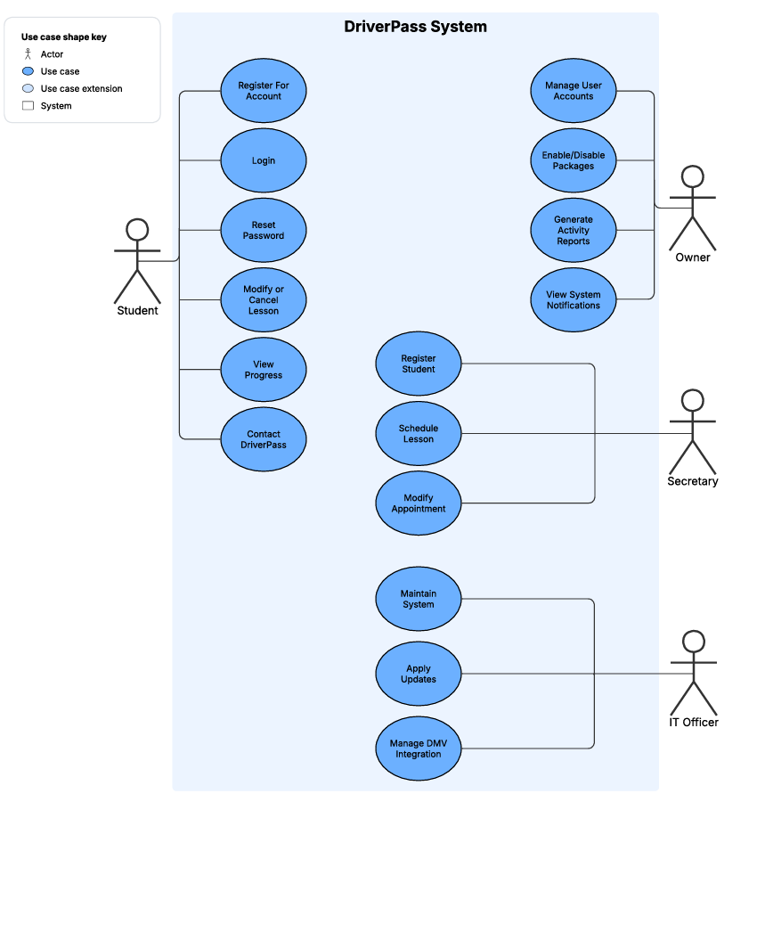

### UML Activity Diagrams

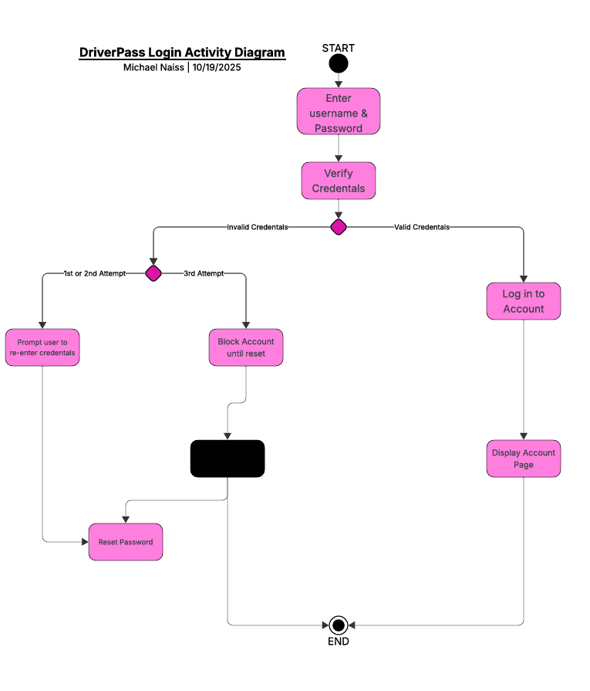

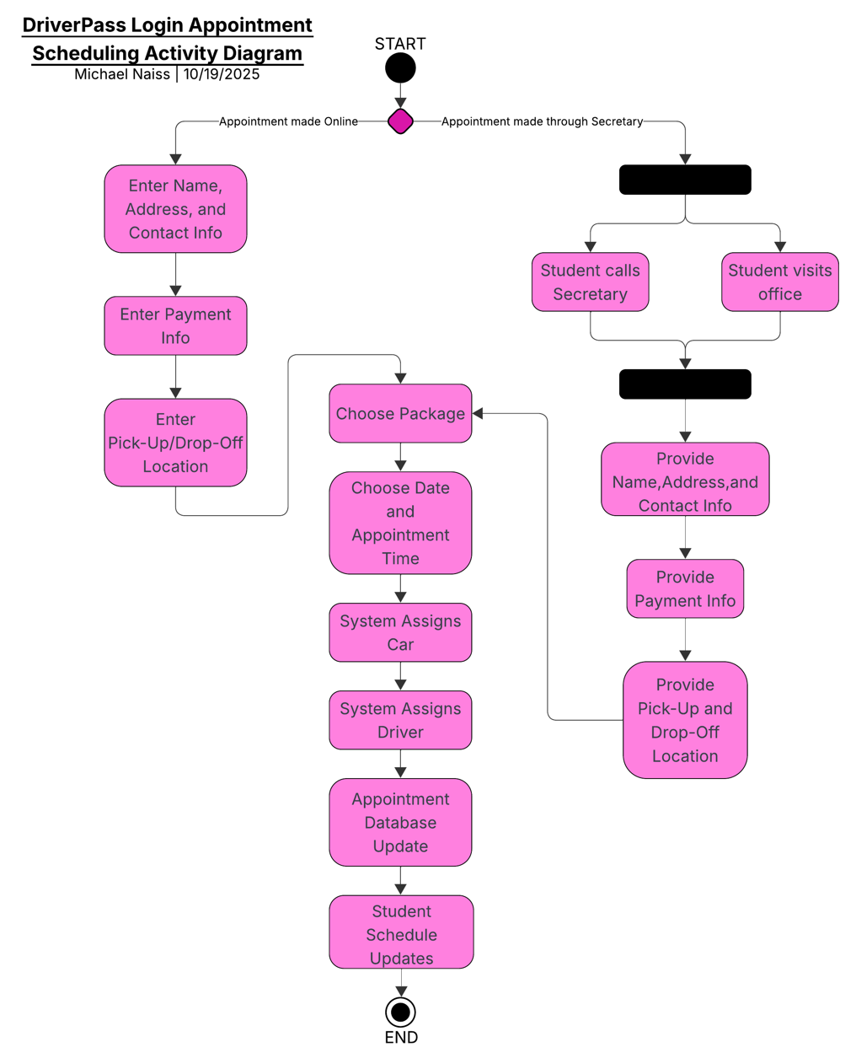

### UML Sequence Diagram

### UML Class Diagram

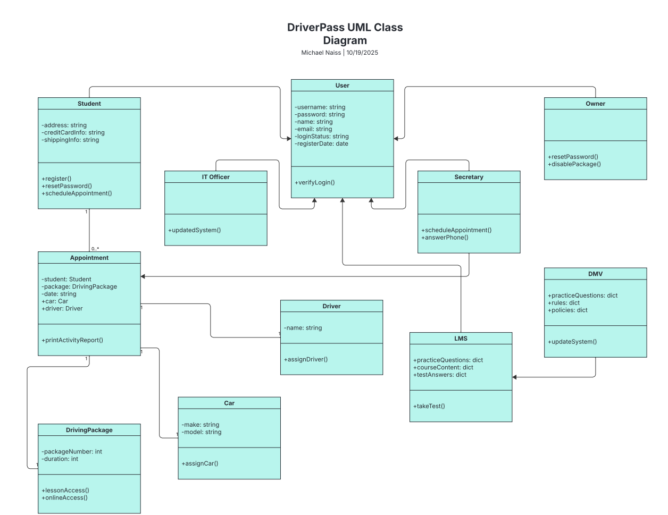

## Technical Requirements

The DriverPass system is designed to operate as a web-based application hosted on a cloud server. This server will store all essential databases, including those for user accounts, appointment scheduling, vehicles, drivers, and any additional data added during future updates. To handle financial transactions, the system must integrate with a third-party payment platform such as PayPal. Development will be carried out using the Java programming language, requiring an IDE that supports efficient collaboration among Java developers. Additionally, the system’s infrastructure must be capable of automatically receiving updates from local DMV databases to ensure information remains current.